**DOCUMENT 5:**

**Death Notice of Dinah Mason White**

*Note: Spooner’s Vermont Journal was a newspaper published in Windsor, Vermont.*

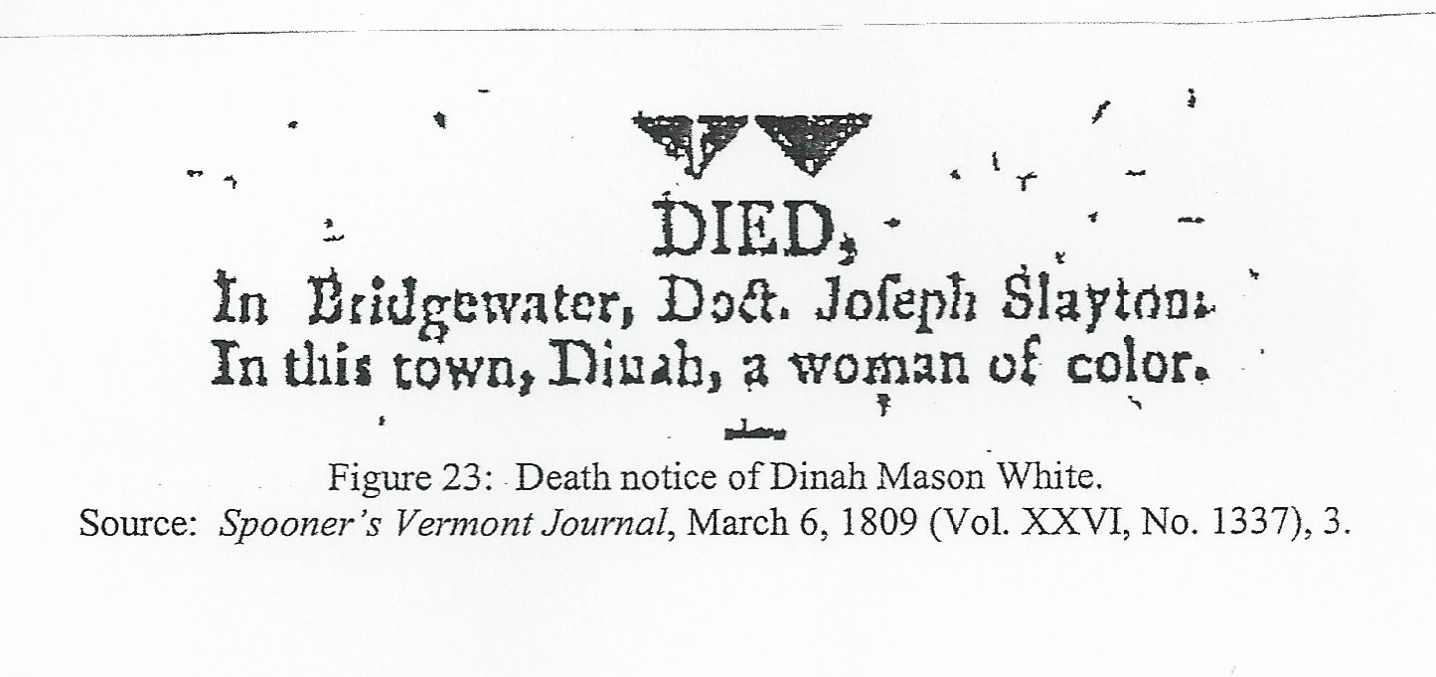

**Source the Document:**

What is this document?

Where was it published?

When was it published?

**Read the Document Closely:**

Describe in your own words what this newspaper clipping is announcing about Dinah:

**Analyze the Document:**

Compare Dinah Mason White’s death notice with Joseph Slayton’s. What differences do you note and why might there be such differences?