**DOCUMENT 4**

**WINDSOR, VT: Poor Records 1809**

Towns were required to care for those who were too poor or sick to care for themselves or whose families could not care for them. Often they paid townspeople to “keep” an ill or poor person in their home, providing food, clothing, and shelter. They also paid doctors to “attend” or care for the ill. Towns only wanted to support people who had been born in town. They would “warn” other people out, sending them to their hometowns for care.

**TASK:** Find each of these dates and Dinah’s name. Write down who was helping her and what they were doing. Then, write a paragraph summary of what you have learned. If you need help reading the document, there is some typed help on the last page.

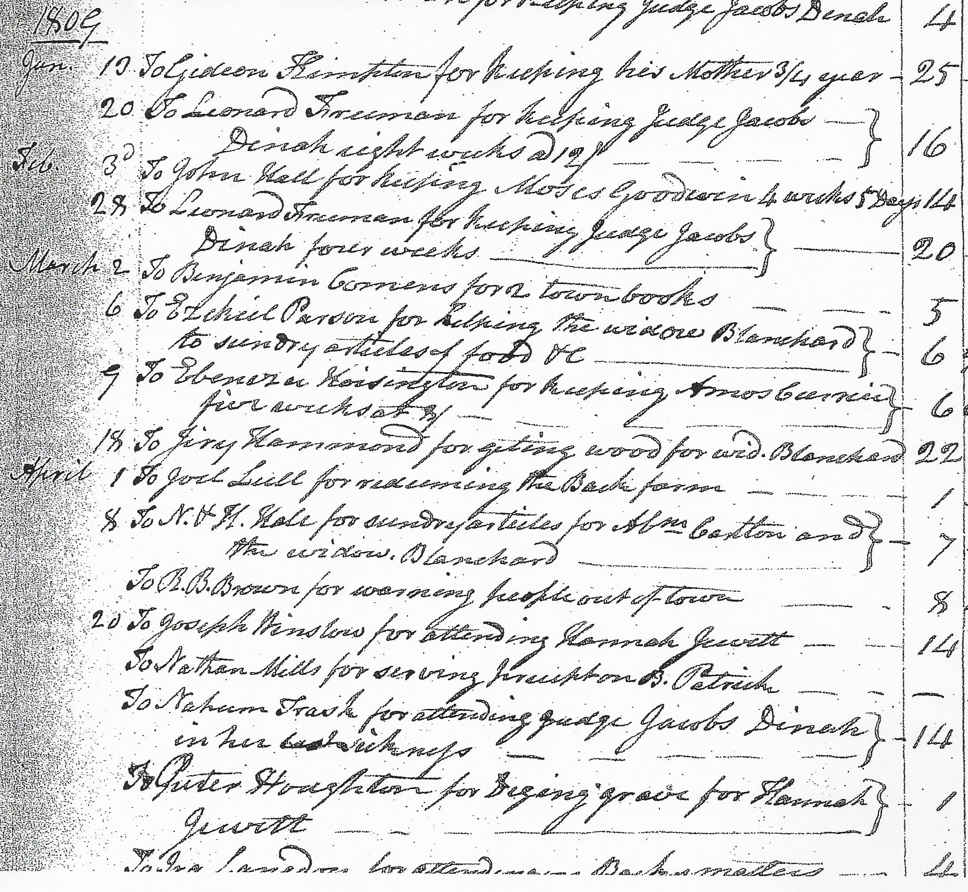

**January 20:**

**February 28:**

**April 20:**

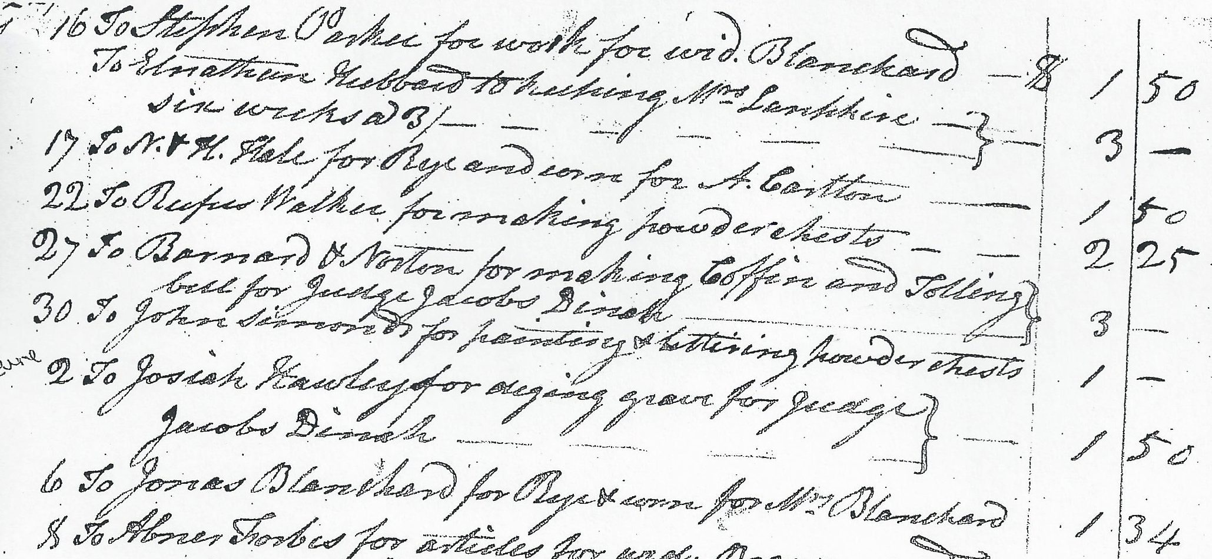

**May 27:**

**June 2:**

**Write a paragraph summary of Dinah’s Story in 1809**

**Transcription Help:**

Jan. 20, 1809: To Leonard Freeman for helping Judge Jacob’s Dinah ...eight weeks @12

Feb. 28, 1809: To Leonard Freeman for keeping Judge Jacob’s Dinah ...four weeks

April 20, 1809: To Nahum Trask for attending Judge Jacobs Dinah in her bed sickness

May 27, 1809: To Barnard Norton for making coffin and tolling bell for Judge Jacobs Dinah

June 2, 1809: To Josiah Hawley for digging grave for Judge Jacobs Dinah