DOCUMENT 3: Town Meeting Notice
(this document is typed on the next page)

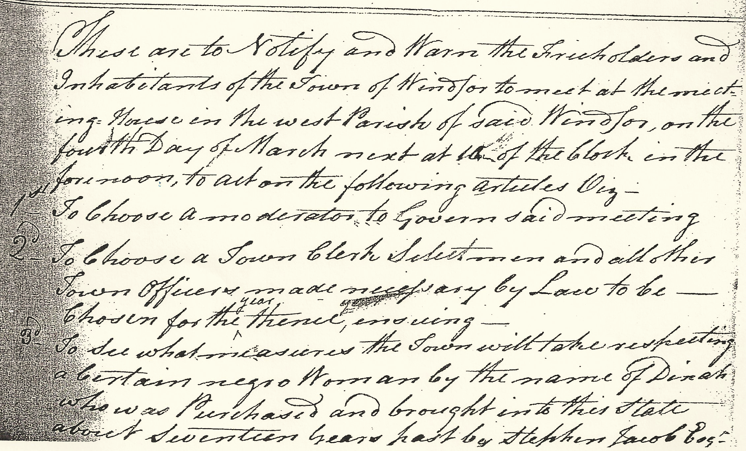

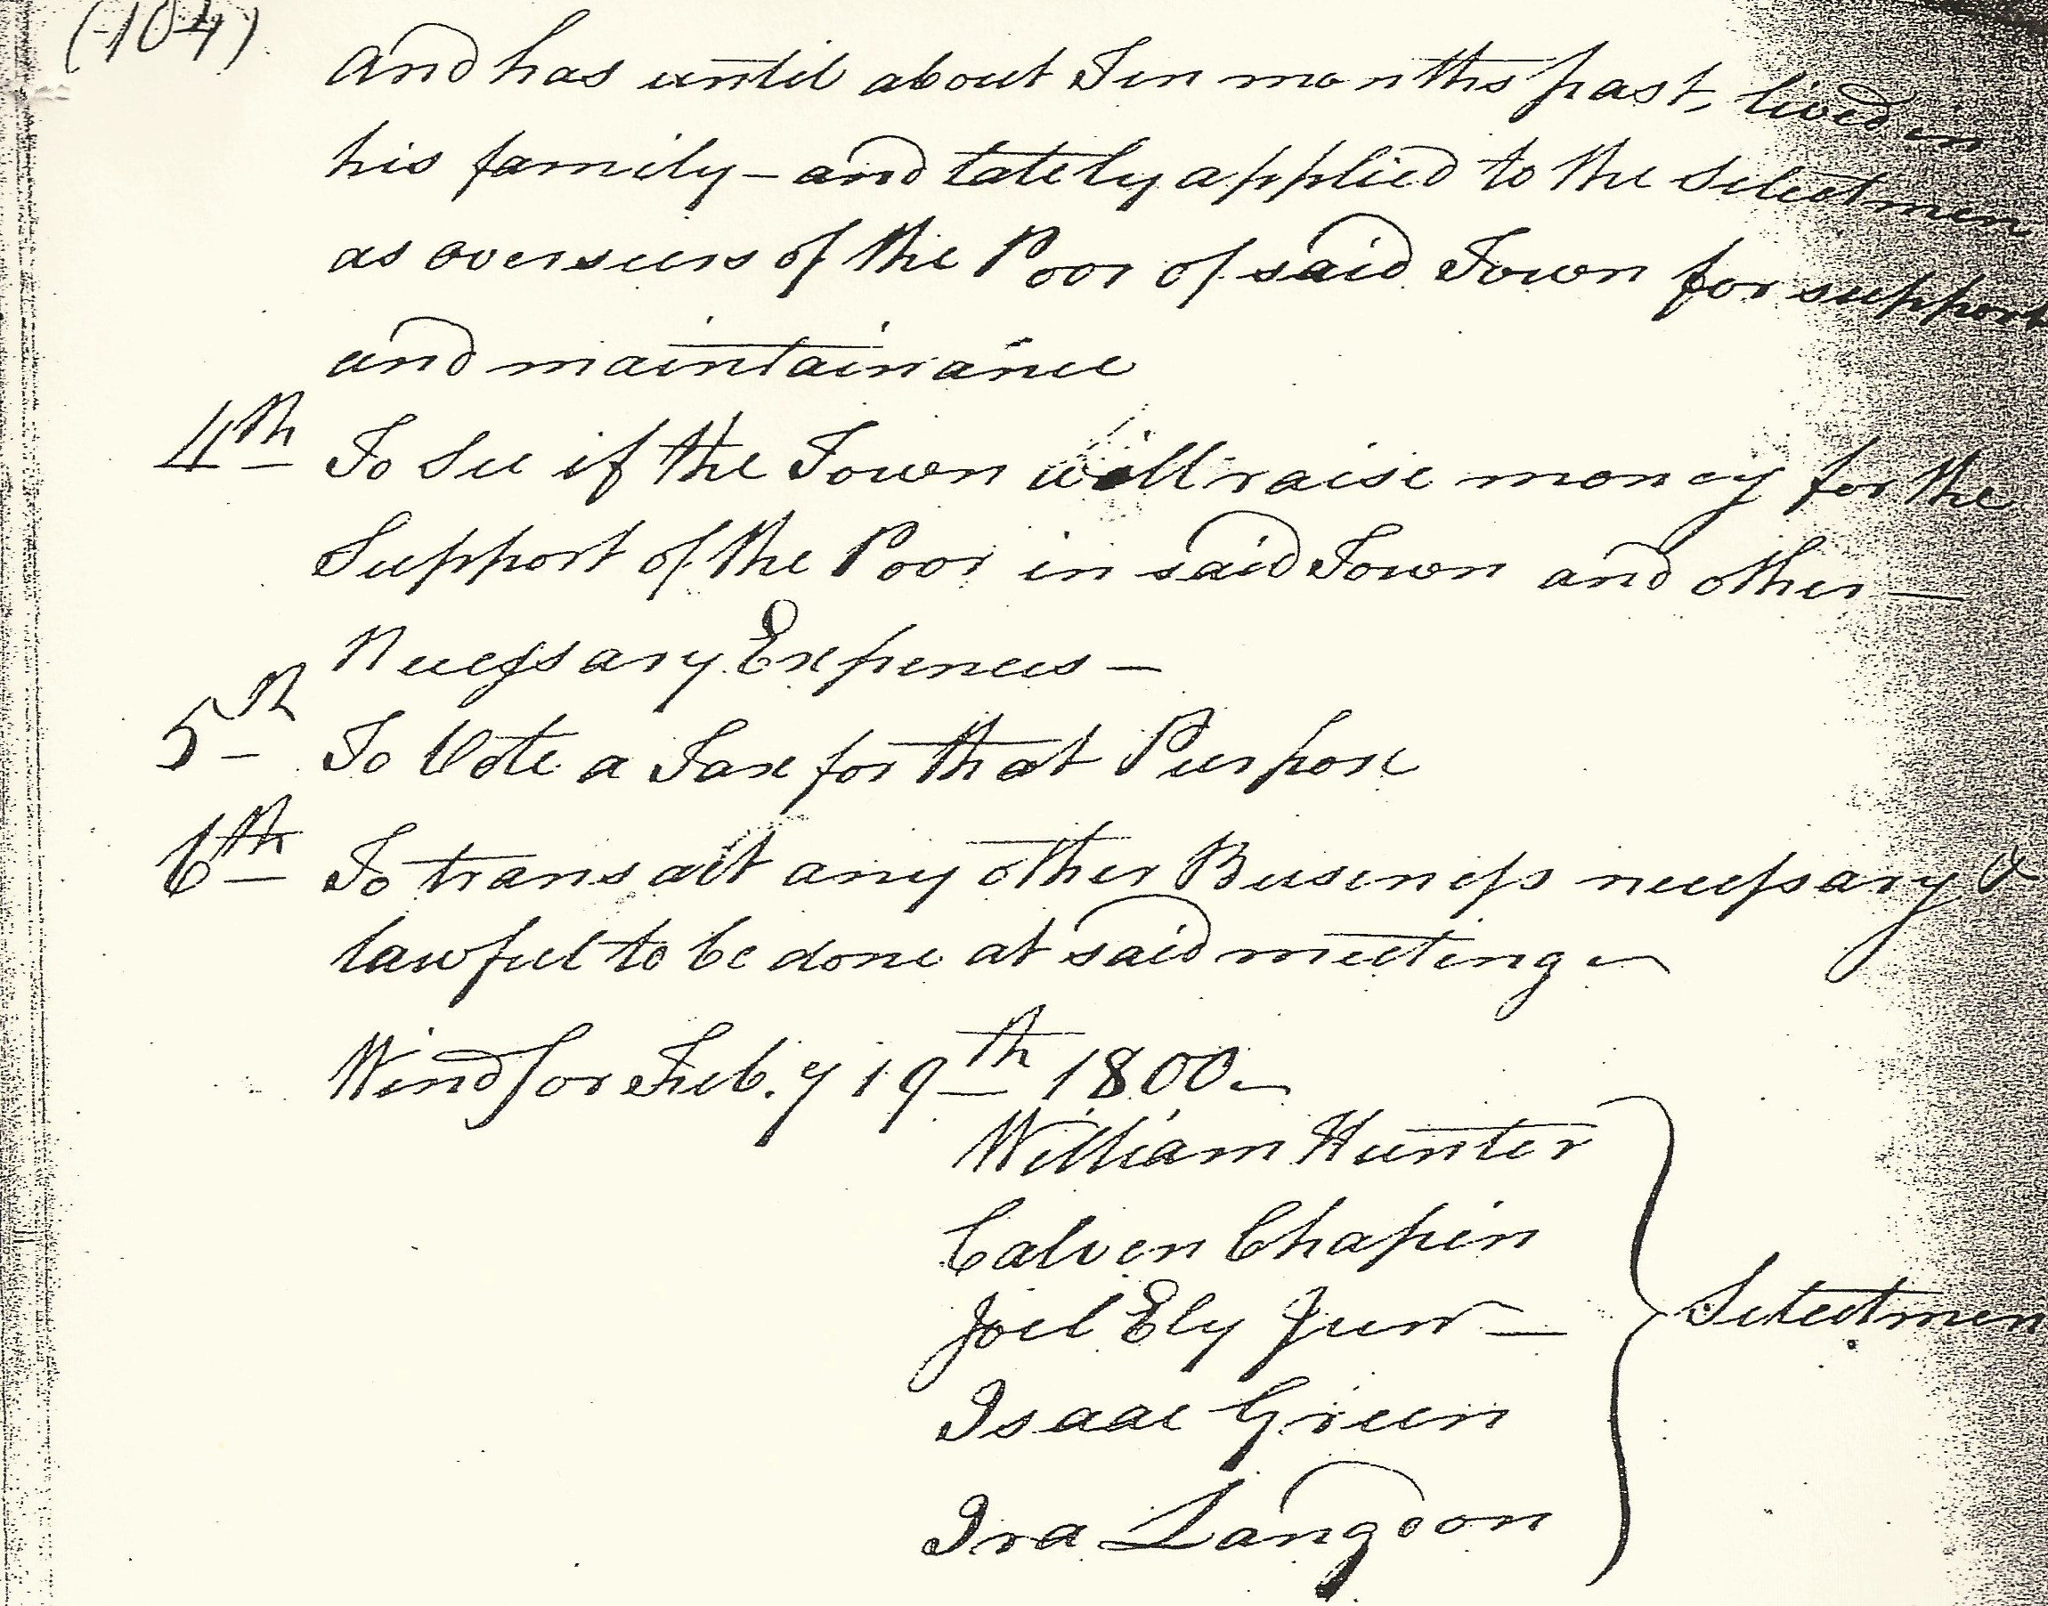

Transcription:
These are to Notify and Warn the Freeholders and Inhabitants of the Town of Windsor to meet at the meeting House in the west Parish of said Windsor, on the fourth Day of March next at 10 of the Clock in the forenoon, to act on the following articles Viz –

1st To Choose a moderator to Govern said meeting

2 To Choose a Town Clerk Selectman and all other Town Officers made necessary by Law to be—Chosen for the year thence, ensuing—

3. To see what measures the town will take respecting a certain negro Woman by the name of Dinah who was Purchased and brought into this state about Seventeen years past by Stephen Jacob Esq.and has until about Ten months past, lived in his family—and lately applied to the Selectmen as overseers of the Poor of said Town for support and maintenance.

4th To see if the Town will raise money for the Support of the Poor in said Town and other Necessary Expenses—

5th To Vote a tax for that Purpose
6th To transact any other Business necessary & lawful to be done at said meeting—

Windsor Feby 19th 1800
William Hunter
Calvin Chapin Selectmen
Joel Ely Junr
Isaac Green
Ira Langdon

DOCUMENT 3 WORKSHEET: Windsor Town Meeting Notice

Source the Document:

What is this document?

Where was it published?

When was it published?

Read the Document Closely:

Find the reference to Dinah.
Write in your own words what the voters are going to decide:

Analyze the Document:

How old was Dinah when she was brought to Windsor?

How do you think the town defines Dinah’s status? Is she free or enslaved?
What makes you say that?

Does she still live with Stephen Jacob?

What has Dinah asked from the Overseers of the Poor? Why might that be?

