DOCUMENT 2 WORKSHEET: 1790 Windsor, VT, Census Record
FIRST SOURCE YOUR DOCUMENT | What type of source is this? (letter, photo, etc.) | Who wrote or created the source? | When was it published? | Where was it published?  Where does it take place? | Who is the audience?
READ IT CLOSELY Read the column headings and focus on columns 5 & 6. What do you think “All other free persons” means? Find the name Stephen Jacob—how is Dinah presented as a member of his household? Do other households in Windsor have “other free persons”?

PUT IT IN CONTEXT Why do you think the census says there are no slaves in Stephen Jacob’s household? What do you think about the other “free persons” in column 5 of these Windsor census pages?

1790 Windsor, VT, Census Record
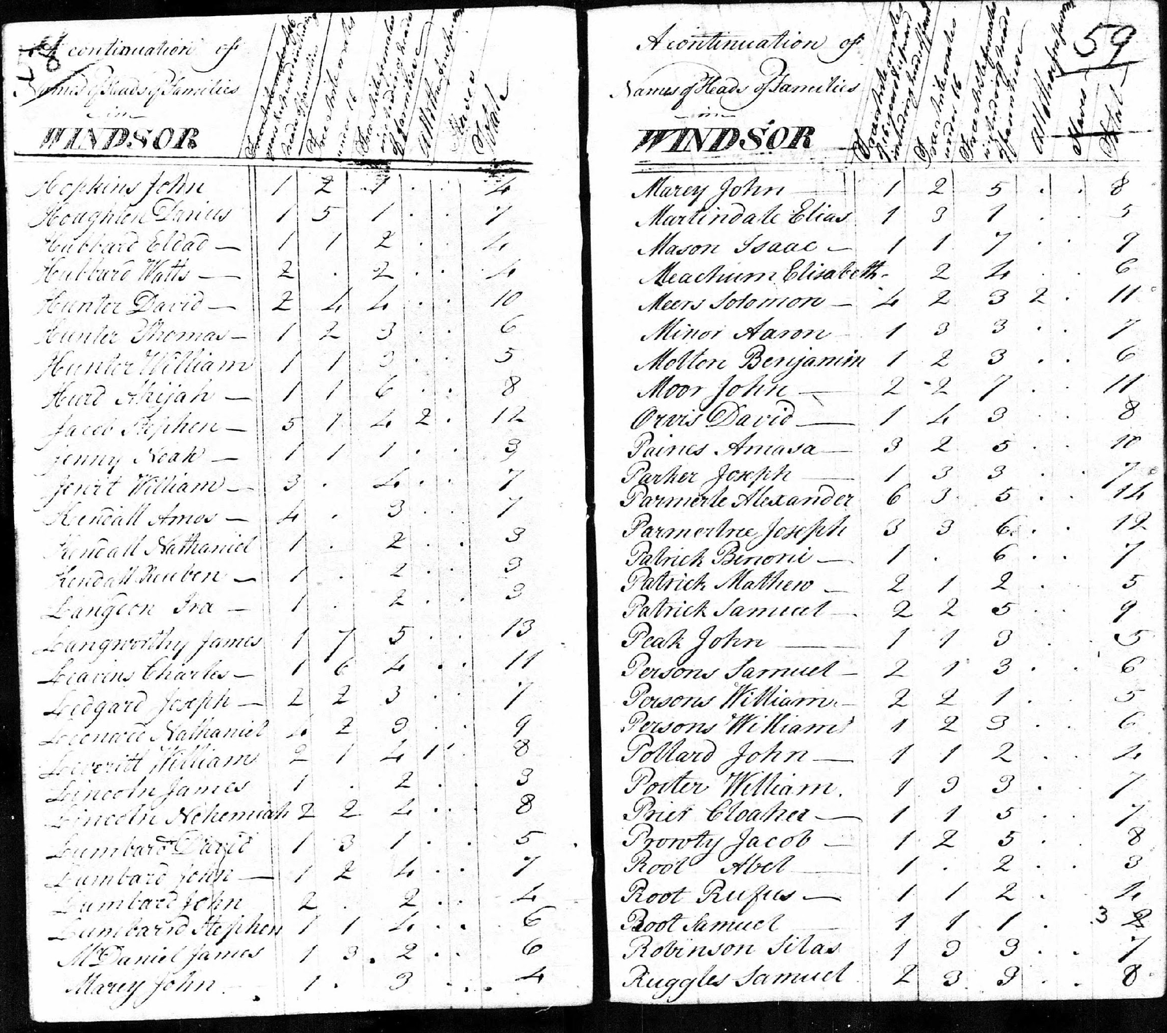
Columns from left to right:

Column 1: Last name, First name

Column 2: White males 16 years and upward including heads of household

Column 3: Free white males under 16

Column 4: Free white females including heads of households

Column 5: All other free persons

Column 6: Slaves

Column 7: Total

