DOCUMENT 1: Bill of Sale
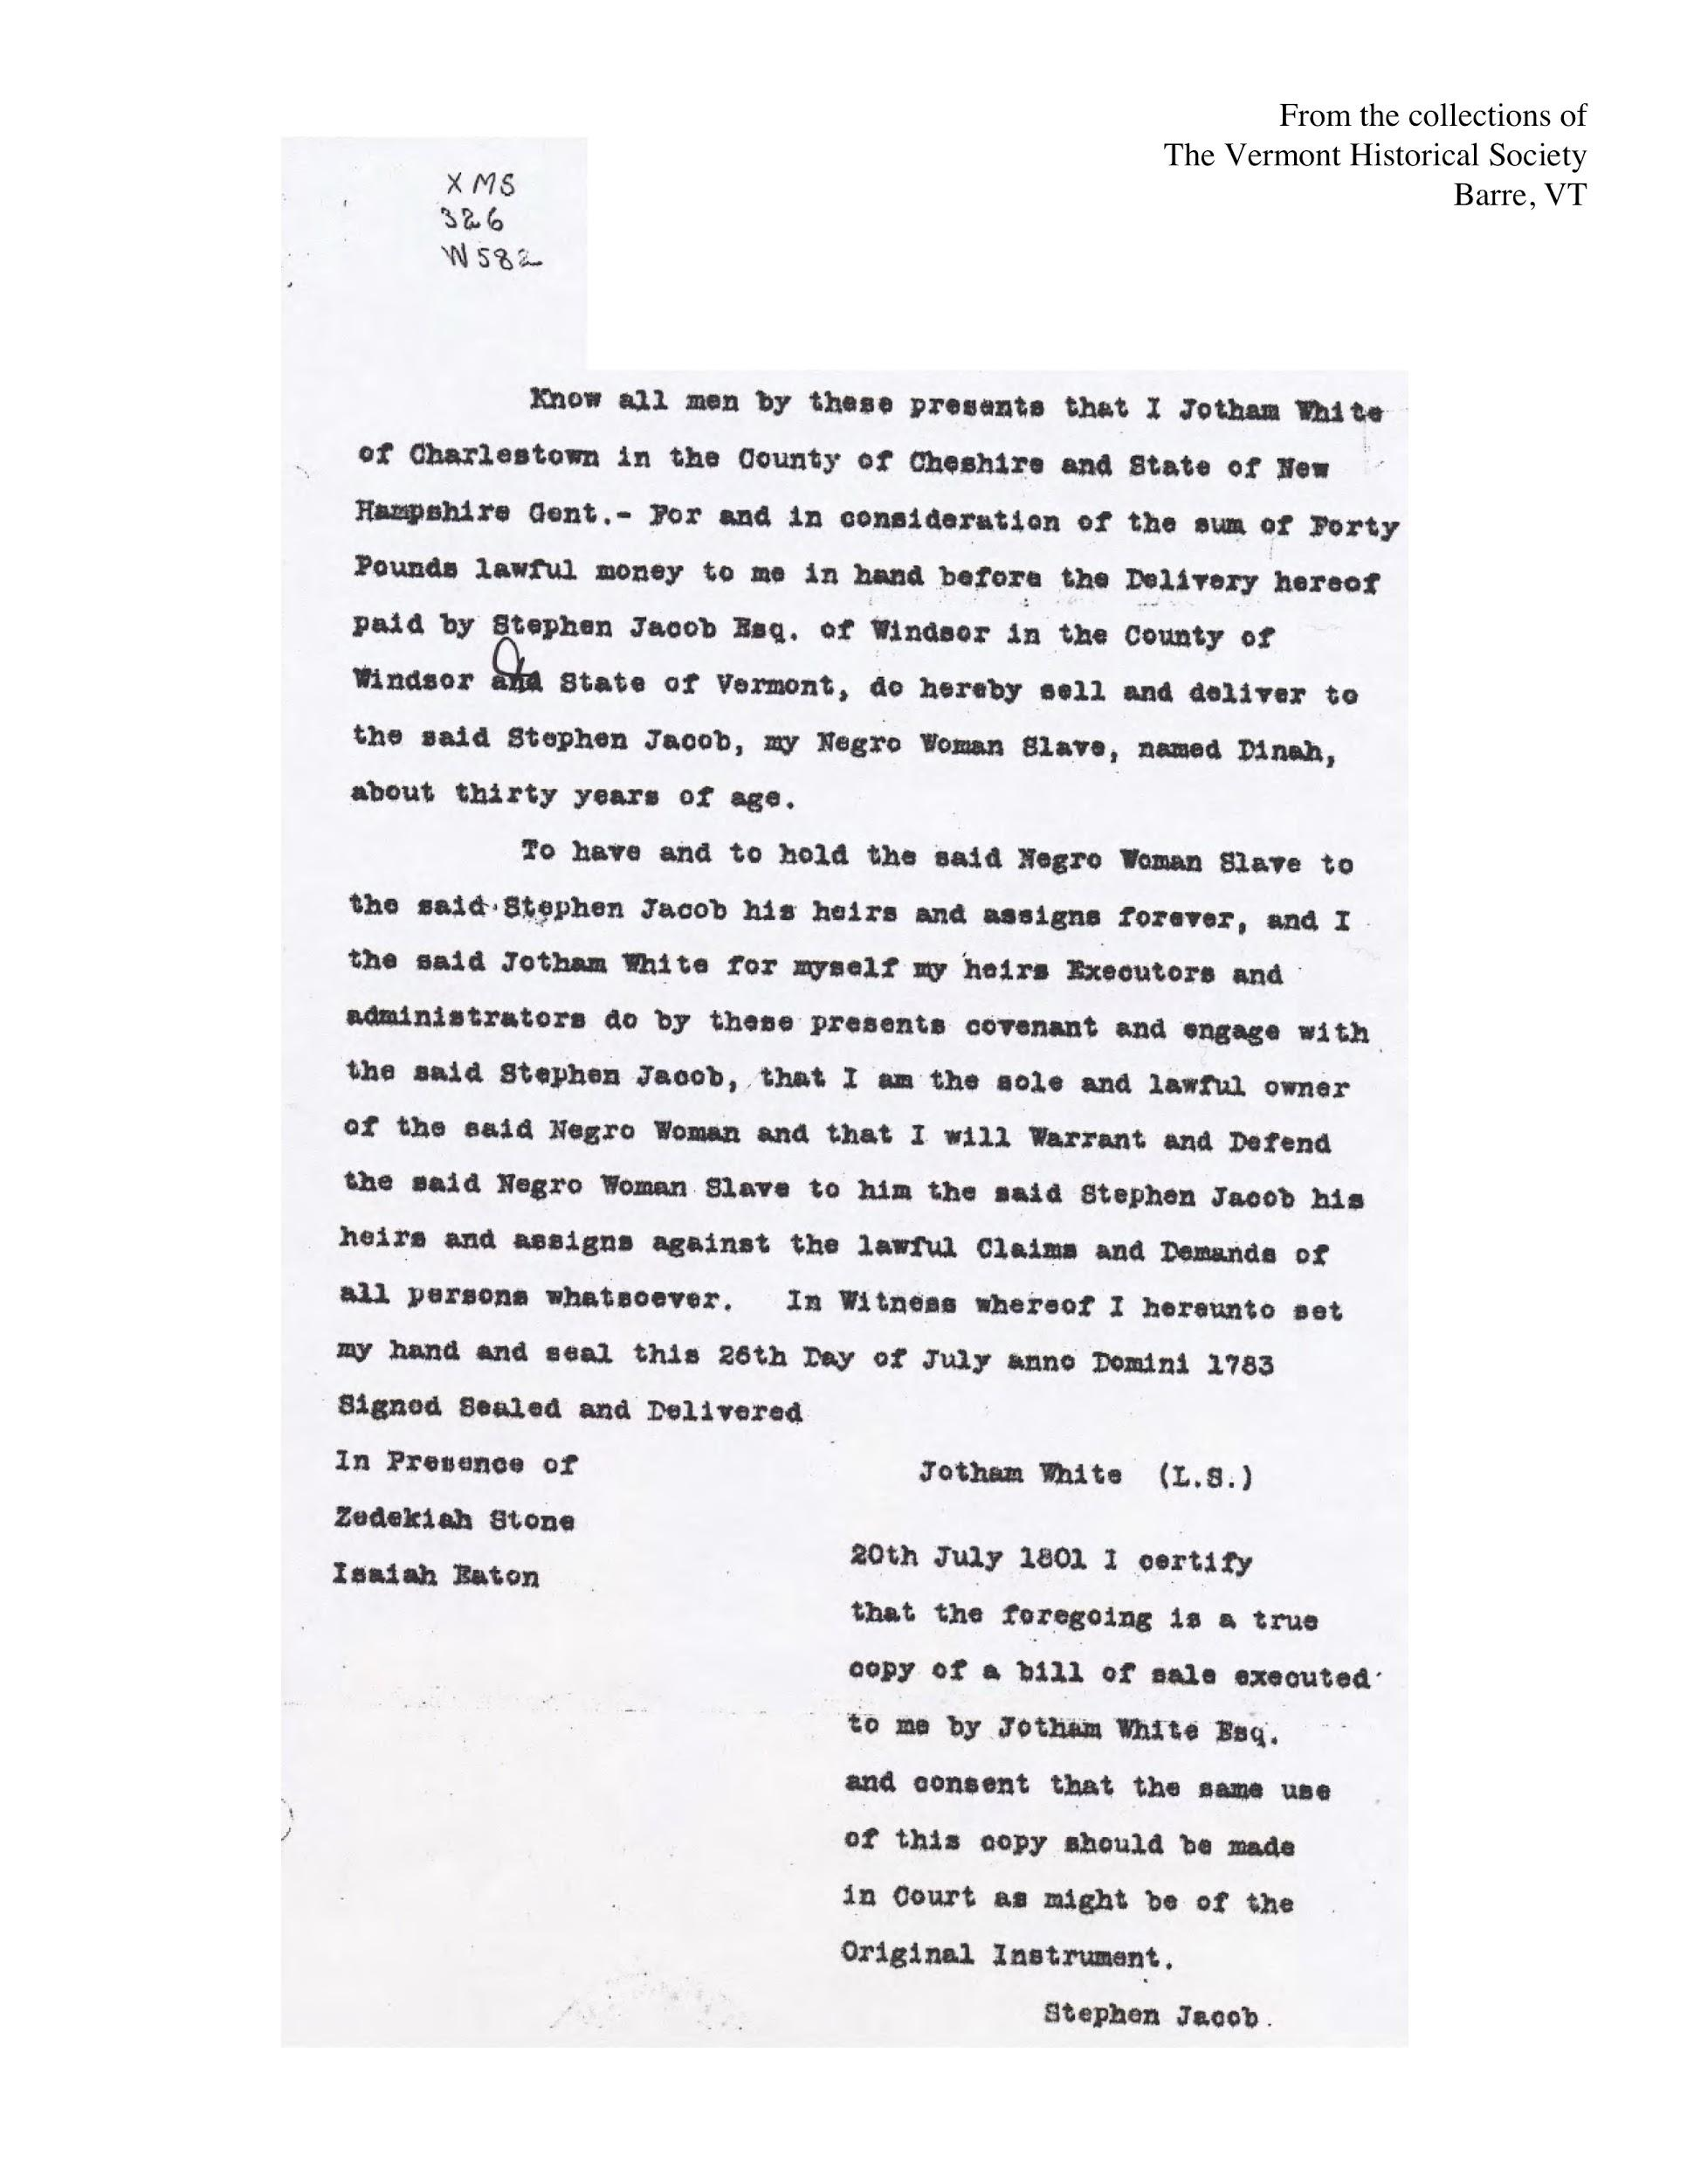
How long is Stephen Jacob to have Dinah?
What is the date of the sale?

Who is Jotham White selling? What is her status?
How old is she?
How much money is Stephen Jacob paying to Jotham White?
DOCUMENT 1 WORKSHEET: Bill of Sale

Summarize the Document—what is happening? Use specific evidence from the text.

Place the Document in Context:

According to the Vermont Constitution, was this sale legal? Why or why not? Include language from the Vermont Constitution in your answer.

