Summary of Population by Towns, 1791

The census-taker counted everyone in town. In your own words, summarize the groups of people he counted. The first category has been filled out for you as an example.

Category | Your Summary
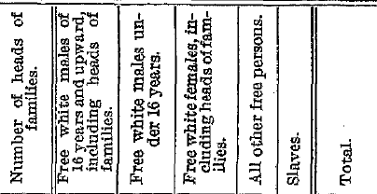 | This is the number of families in the town.

Summary: Compare the 1786 and 1806 laws. How are they similar? Why do you think the Vermont legislature passed the law in 1806? What conclusions would you draw about conditions in Vermont for Black people 30 years after the constitution abolished slavery?

